**DOCTOR APPOINTMENT BOOKING APP**

A THESIS SUBMITTED IN PARTIAL

FULFILLMENT OF THE REQUIREMENT FOR THE DEGREE OF

**BACHELOR OF TECHNOLOGY**

IN

**COMPUTER SCIENCE AND ENGINEERING**

SUBMITTED BY

VIKASH TIWARI (12500121106)

RAJ AGRAHARI (12500221053)

ABHISHEK KUMAR MISHRA

(12500121051)

UNDER THE GUIDANCE OF

**Mr. JHUNTU**

Assistant Professor



DEPARTMENT OF COMPUTER SCIENCE AND ENGINEERING

**BENGAL COLLEGE OF ENGINEERING AND TECHNOLOGY**

AFFILIATED TO

MAULANA ABUL KALAM AZAD UNIVERSITY OF TECHNOLOGY

# Contents

|  |  |
| --- | --- |
| ***Preliminary*** | |
| ▪ | Title Page |
| ▪ | Certificate of Recommendation |
| ▪ | Certificate of Approval |
| ▪ | Abstract |
| ▪ | Acknowledgements |
| ▪ | List of Figures |
| ▪ | List of Tables |
| ▪ | List of Symbols and Abbreviations |
| ▪ | List of Appendices |
| ▪ | 2nd page of Turnitin Report |
| ***Main Body*** | |
| ▪ | Chapter1: Introduction |
| ▪ | Chapter2:Literature Review |
| ▪ | Chapter3:Methodology |
| ▪ | Chapter4:Results & Discussion |
| ▪ | Chapter5:Future Scope  Chapter 6: Conclusion |
| ▪ | References(A consolidated list of references for all chapters) |
| ***Supplementary*** | |
| ▪ | List of Publications and Papers Presented |
| ▪ | Appendix |

*CertificateofRecommendation*

I here by recommend that the preliminary project report entitled, “**DOCTOR APPOINTMENT BOOKING APP**” carried out under my supervision by the group of students listed below may be accepted in partial fulfillment of the requirement for the degree of “Bachelor of

Technology in Computer Science and Engineering”of BENGAL COLLEGE OF ENGINEERING AND TECHNOLOGY under MAULANA ABUL KALAM AZAD UNIVERSITY OF TECHNOLOGY.

VIKASH TIWARI (12500121106)

RAJ AGRAHARI (12500221053)

ABHISHEK KUMAR MISHRA

(12500121051)

…………………………………

**Mr. JHUNTU**

Project Supervisor

Dept .of Computer Science and Engineering,

Bengal College of Engineering and Technology,

Durgapur-713206

Countersigned:

……………………………… ………………………………

SK. Abdul Rahim Prof.(dr.)Ratul Kumar Majumdar Head of the Department Project Coordinator

Dept. of Computer Science and Engineering, Dept. of Computer Science and Engineering,

Bengal College of Engineering and Technology , Bengal College of Engineering and Technology,

Durgapur-713206 Durgapur- 713206

………………………………

Mr. Swarup kr. Hazra Choudhury Project Convener

Dept. of Computer Science and Engineering,

Bengal College of Engineering and Technology, Durgapur-713206

# Certificate of Approval

The forgoing thesis is here by approved as creditable study of an engineering subject, carried out and presented in a manner satisfactory to warrant its acceptance as prerequisite to the degree for which it has been submitted. It is understood that by this approval the undersigned does not necessarily endorse or approve any statement made, opinion expressed or conclusion drawn therein but approve the thesis only for the purpose for which it is submitted.

……………………………………….

(**Mr. JHUNTU**)

Project Supervisor

Dept. of Computer Science and Engineering, Bengal College of Engineering and Technolog,

Durgapur-713206

# ACKNOWLEDGEMENT

It is our great privilege to express our profound and sincere gratitude to our Project Supervisor, **Mr. JHUNTU** for providing us a very cooperative and precious guidance at every stage of the present project work being carried out under her supervision. Her valuable advice and instructions in carrying out the present study has been a very rewarding and pleasurable experience that has greatly benefited us throughout the course of work.

We would like to convey our sincere gratitude towards SK. Abdul Rahim, Head of the Department of **Computer Science and Engineering**, Bengal College of Engineering and Technology for providing us with the requisite support for timely completion of our work. We would also like to pay our heartiest thanks and gratitude to all the teachers of the Department of **Computer Science and Engineering**, Bengal College of Engineering and Technology for various suggestions being provided in attaining success in our work.

We would like to express our earnest thanks to **Mr. JHUNTU**, of IT Project Lab for Her technical assistance provided during our project work.

Finally, we would like to express our deep sense of gratitude to our parents for their constant motivation and support throughout our work.

…………………………………

Vikash Tiwari

…………………………………

Raj Agrahari

………………………………… Abhishek Kumar Mishra

***Abstract***

This app helps people book appointments with doctors using their phone or computer. Instead of going to the hospital or clinic to fix an appointment, users can choose a doctor, pick a date and time, and book a visit from anywhere. The app shows details like doctor’s name, specialty, and available times. It also sends reminders so users don’t forget their appointments. This app saves time and makes it easier for patients to get medical help.

**List of Figures**

Fig.1.1 Data flow digram

INTRODUCTION

Today, many people use mobile phones and the internet for daily work. Going to the hospital to book a doctor’s appointment can take a lot of time. Sometimes, people have to wait in long lines. To make this easier, we can use a Doctor Appointment Booking App. This app helps patients book appointments with doctors quickly and easily. People can see which doctors are available, choose a time, and book their visit from home. This saves time and helps patients get better care.

In today’s fast-moving world, people are becoming very busy. Everyone wants to save time and do things quickly. One of the important things in life is health. When someone feels sick or needs to visit a doctor, they have to go to the hospital or clinic. Many times, patients have to wait in long lines just to book an appointment. This takes a lot of time and is also uncomfortable, especially for those who are not feeling well.

Technology is growing every day. Now, we use mobile phones and the internet for many things like shopping, studying, or talking to friends. In the same way, we can also use technology to book doctor appointments. A Doctor Appointment Booking App is a useful tool that helps people book appointments with doctors without going to the hospital. This app is easy to use and saves time for both doctors and patients.

With this app, a patient can see the list of doctors, their specialties (like heart doctor, skin doctor, etc.), available days, and times. The patient can then choose a doctor and book the appointment with just a few clicks. The app can also show the location of the clinic or hospital, and it can send reminders to the patient so they don’t forget the appointment.

The app is helpful in many ways. First, it removes the need to stand in line or wait for a long time. Second, it helps people who live far from hospitals. They can book their visit from home. Third, the app also helps doctors to manage their time better. They can see their schedule clearly and plan their day properly. This reduces confusion and helps give better care to each patient

## LITERATURE REVIEW

Many researchers and developers have studied how to make booking doctor appointments easier using mobile apps or websites. In the past, patients had to visit hospitals or clinics to fix a doctor’s appointment. This was time-consuming and often caused long waiting times. As technology improved, many apps and systems were made to solve this problem.

Some research papers talk about online health systems that let patients book appointments through websites. These systems allow patients to see available doctors, choose a time, and get confirmation. This saves time and makes it easy for both the patient and the doctor.

Other studies focus on mobile apps. Mobile apps are even more popular because most people use smartphones. Apps like Practo, Zocdoc, and Doctolib are examples of this. These apps allow users to search for doctors by name, area, or specialty, and book an appointment from anywhere at any time.

Some researchers also mention extra features in these apps like video calling with doctors, online payment, reminders, and patient health records. These features help improve the patient’s overall experience.

Studies show that these apps are helpful during emergencies, lockdowns, or when people are in remote areas. They reduce the need to travel and help doctors manage their time better. But some papers also talk about problems like internet issues, older people not knowing how to use apps, and data privacy concerns.

In summary, many studies agree that doctor appointment booking apps are useful and needed in today’s world. They make healthcare faster, easier, and more comfortable for everyone. Still, there is room for improvement to make these apps more secure, simple, and user-friendly for all types of users.

## METHODOLOGY

The methodology explains how the Doctor Appointment Booking App is planned, designed, and developed. It shows the steps followed to build the app in a simple and clear way.

First, we studied the problems that patients and doctors face with the old system of booking appointments. Patients often wait in long lines, and doctors face trouble managing many people at the same time. After understanding these problems, we decided to make an app that can help both doctors and patients.

Next, we collected information about how similar apps work, like Practo and Zocdoc. We looked at their features and found out what is good and what can be improved. This helped us to plan the features of our app.

Then, we made a simple design for the app. We created sample screens to show how the app would look. This included the login page, doctor list, booking page, and confirmation page. We kept the design clean and easy so that anyone can use it, even people who are not good with technology.

After that, we started building the app using programming languages like Java or Kotlin for Android, or Flutter for both Android and iOS. A database was also used to store user information, doctor details, and booking data.

We tested the app with a few users to see if everything works well. We asked for feedback to make the app better. If any problem was found, we fixed it before finishing the final version.

In the end, the app was ready to use. It allows users to sign up, see doctor details, book appointments, and get reminders. This step-by-step method helped us build a simple, useful, and user-friendly doctor appointment app.

### Flow Diagram

Fill the form/ login to the page

|

Check the Authentation

|

Pass the prompt to AI

|

Save the result to firebase

|

Results Displayed

**DFD - Level 0 (Context Level)**

This shows the system as a whole and how it interacts with external users.

* **Doctor**: Can log in, view appointments, and manage availability.
* **System**: Connects both doctor and patient, and stores data in the database.

**DFD - Level 1**

This breaks down the system into smaller parts (processes).

**Processes:**

1. **Register/Login**: User logs in or creates a new account.
2. **View Doctors**: Patient views available doctors, specialties, and times.
3. **Book Appointment**: Patient selects a doctor, date, and time.
4. **Doctor Login**: Doctor logs in to access their schedule.
5. **Notification System**: Sends confirmation and reminders to patients.
6. **Manage Schedule**: Doctor updates available time slots.

**Databases:**

* **Appointment Database**: Stores all booking data.
* **Doctor Database**: Stores doctor details and availability.
* **Patient Database**: (Not shown in the diagram but usually part of the system.)

*RESULT ANALYSIS*

1. **coding and output**
2. 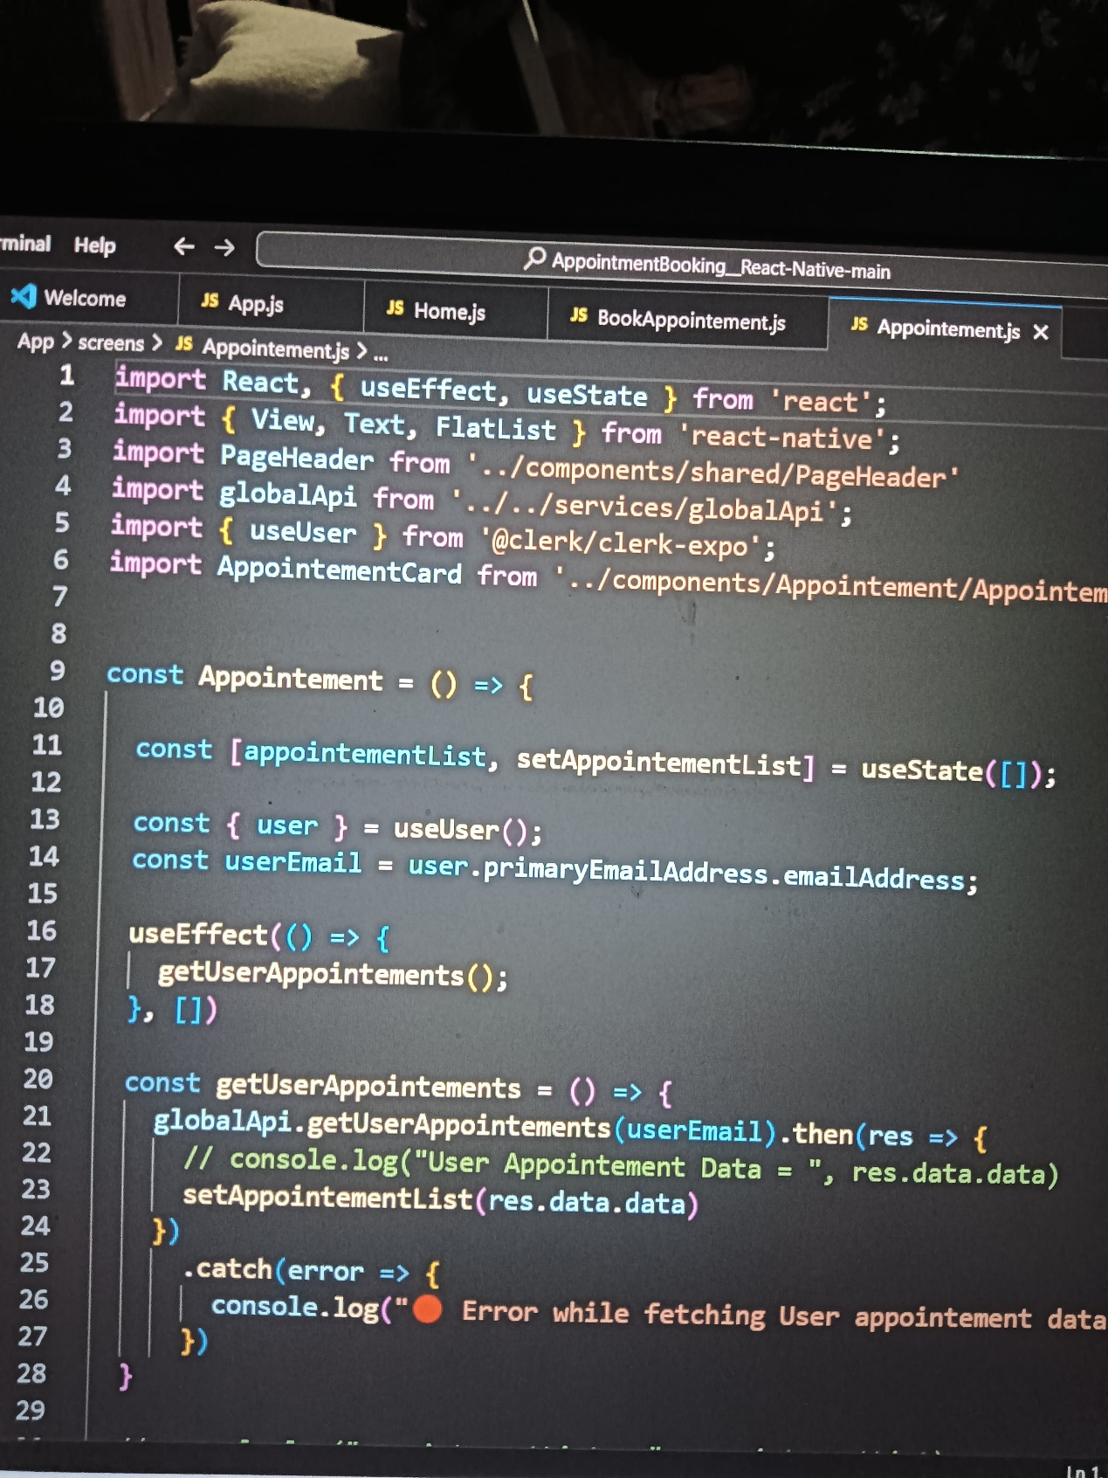

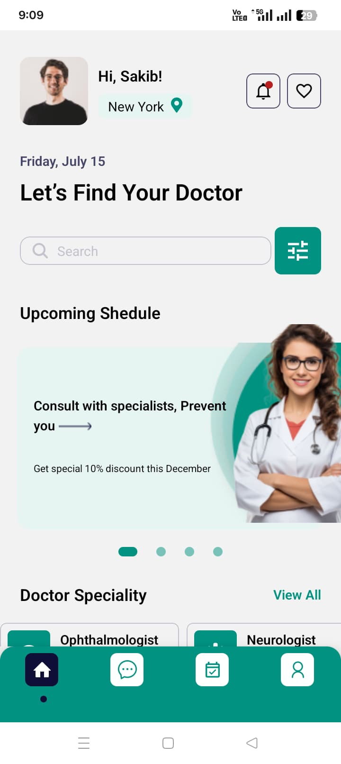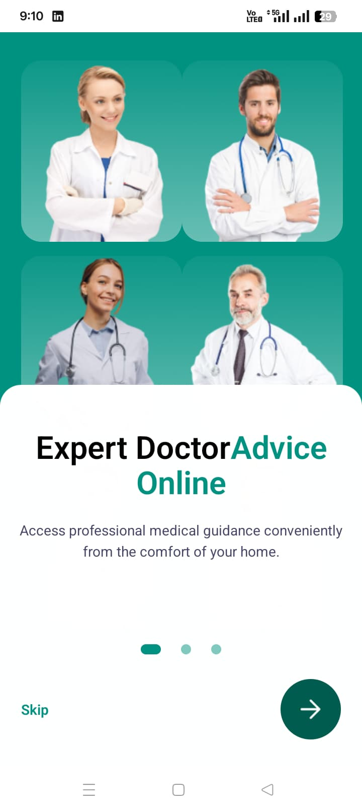

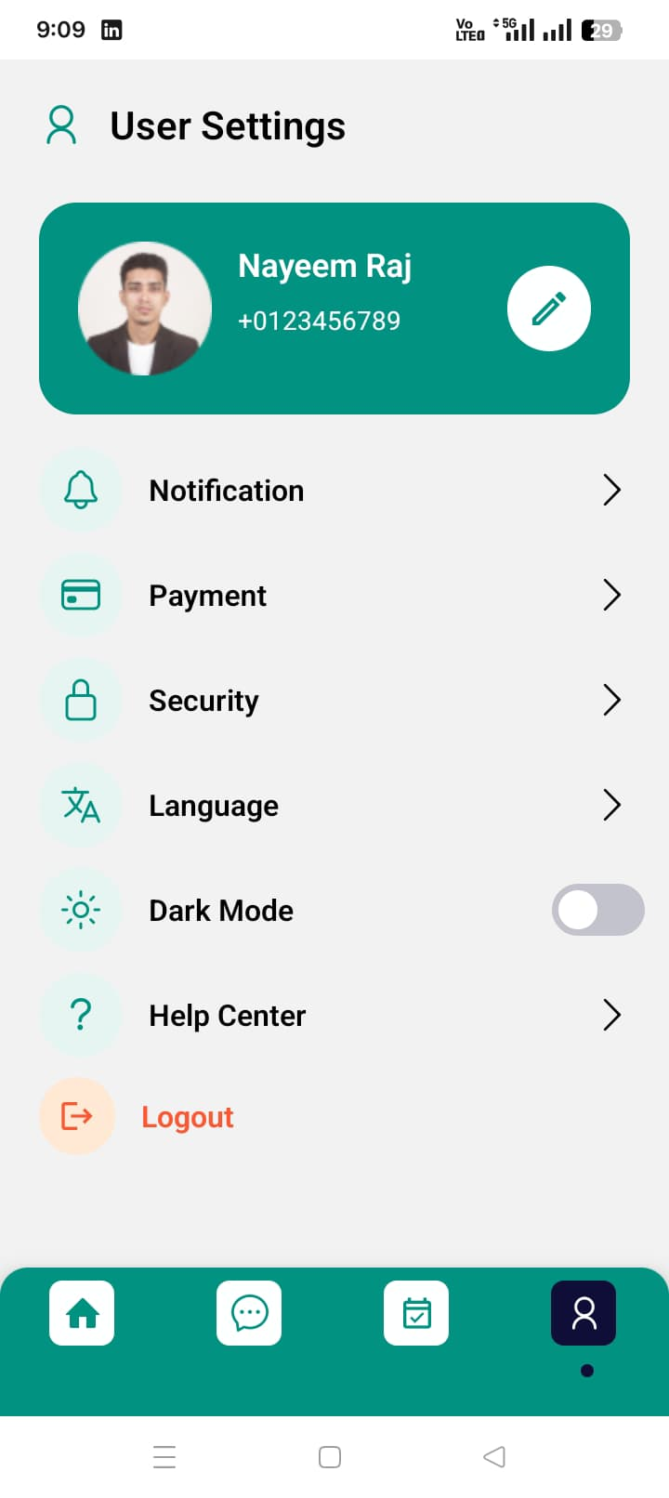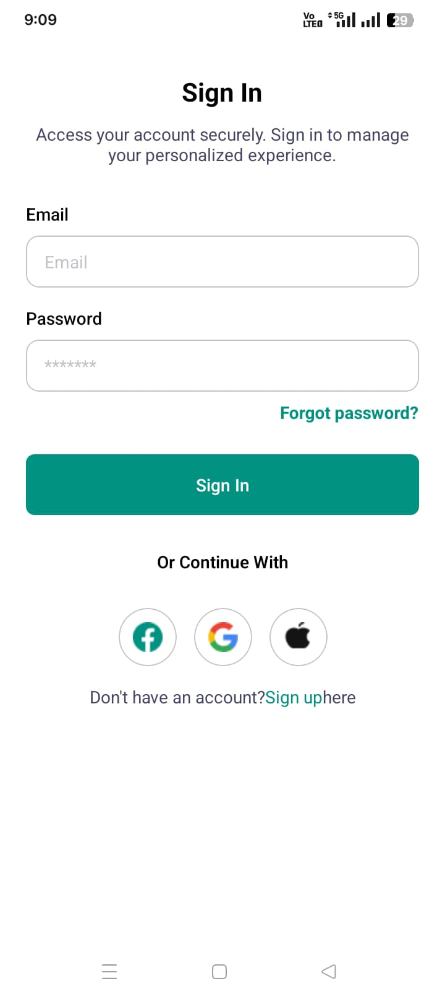

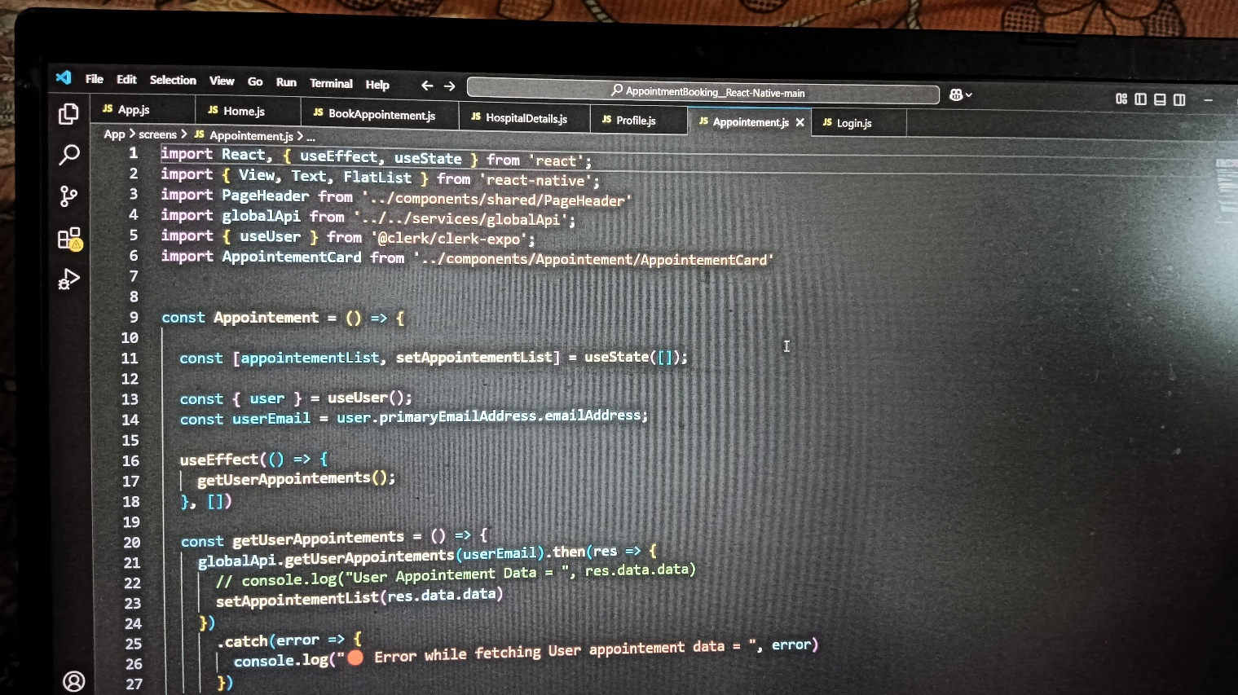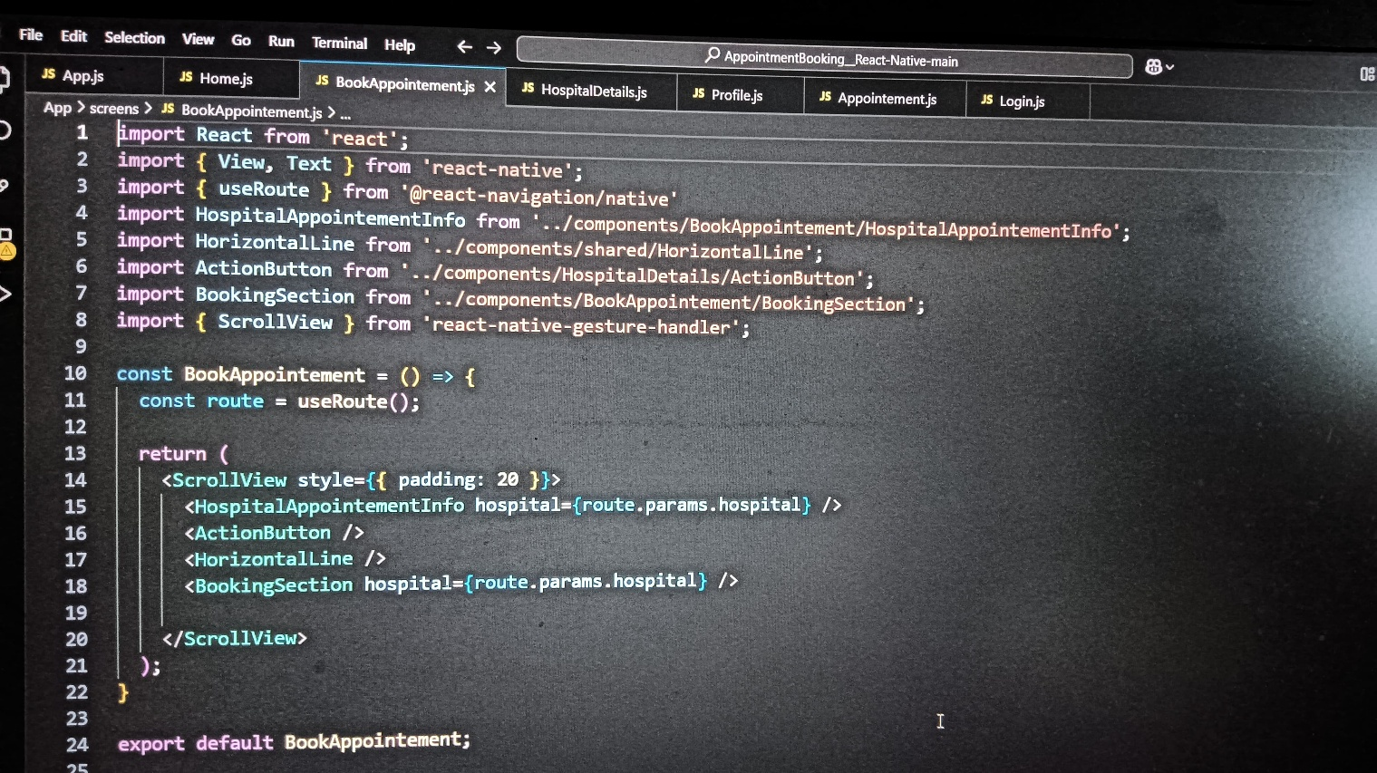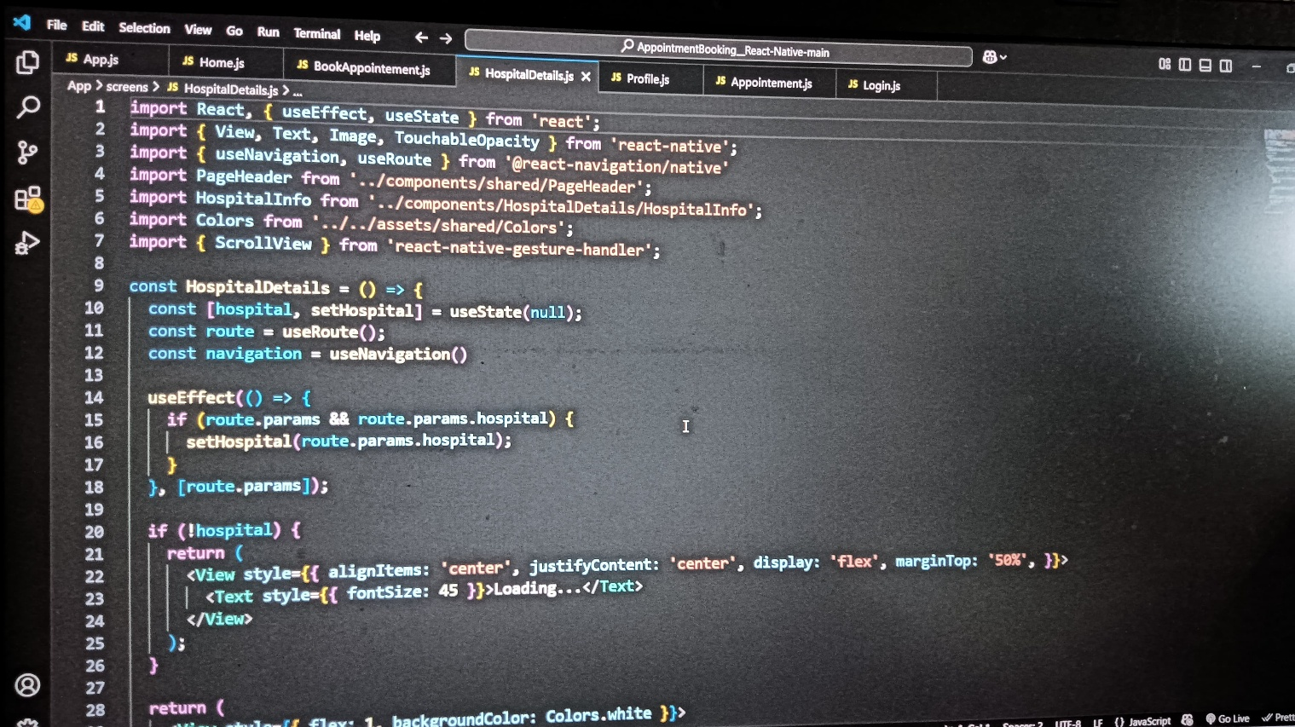

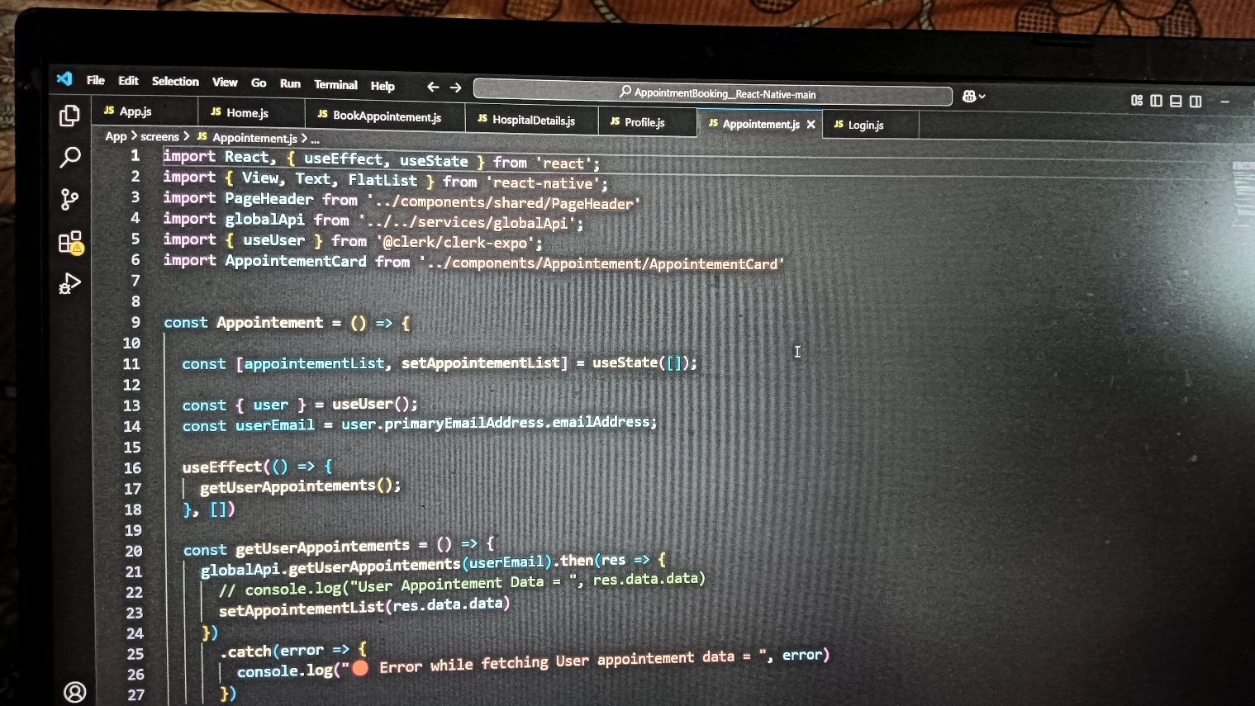

## FUTURE SCOPE

The Doctor Appointment Booking App is very helpful now, but it can become even better in the future. As technology keeps growing, we can add more features to make the app smarter and more useful for both patients and doctors.

In the future, the app can include **online video consultations**. This will help patients talk to doctors without visiting the clinic, which is useful during emergencies or when someone is far from a hospital. It can also help in rural areas where fewer doctors are available.

The app can also add **online payment options**, so users can pay for their appointments safely through the app. This makes the process faster and easier.

Another useful feature could be a **health record system**. Patients’ reports, prescriptions, and health history can be saved inside the app. Doctors can check these records anytime, which helps in giving better treatment.

The app can also use **AI (Artificial Intelligence)** in the future. For example, it can give health tips or suggest doctors based on the patient’s symptoms. It can also remind patients to take their medicine or book follow-up visits.

**Multi-language support** can also be added, so people who speak different languages can use the app easily.

In the future, this app can also be connected with **wearable devices** like smartwatches to track heart rate, steps, or sleep. This health data can help doctors understand the patient’s daily health better.

In short, the Doctor Appointment Booking App has a bright future. With more features and better technology, it can become an all-in-one health assistant. It will make healthcare more advanced, easier to access, and better for everyone.

### CONCLUSION

The Doctor Appointment Booking App is a very helpful tool for both patients and doctors. It makes the process of booking appointments simple, fast, and stress-free. In the past, people had to visit hospitals or clinics to take appointments, and many had to wait in long lines. This was a waste of time and very uncomfortable, especially for sick or old people. With this app, they can now book a doctor’s visit from home using a phone or computer.

This app is designed to be user-friendly. Even people who are not very good with technology can use it easily. It shows a list of doctors, their specialties, available dates, and times. The patient can pick a doctor and book a time that suits them. The app also sends reminders, so people don’t forget their appointments.

For doctors, this app helps in managing their time and schedules better. They can check their appointments and update their available times. It reduces confusion and makes the system more organized.

The app can also store important information like patient history, appointment records, and contact details. This helps doctors to understand their patients better and provide the right treatment.

In today’s world, where everything is becoming digital, this kind of app is very useful. It saves time, reduces stress, and improves the overall healthcare experience. It is also helpful during times like the COVID-19 pandemic, where people want to avoid crowded places.

In short, the Doctor Appointment Booking App is a smart and simple way to improve healthcare. It connects doctors and patients easily and makes the appointment process smooth. With more updates in the future, the app can become even better and help more people.

REFERENCES

To create the Doctor Appointment Booking App, we studied different sources like websites, mobile apps, and articles. These helped us understand how the system should work and what features are important. Below are the sources we used in simple words

|  |
| --- |
| htftps://developers.google.com/map |
| https://openweathermap.org/api |
| https://openai.com |
| https://[www.nltk.org/](http://www.nltk.org/) |
| https://www.practo.com/ |
| https://www.zocdoc.com/ |
| https://www.google.com/ |
| https://www.youtube.com/ |
| https://www.GeeksforGeeks.com/ |
| https://www.W3Schools.com/ |

[Type here] [Type here] [Type here]